The state of user input for virtual reality technologies

Jessica Lai

Department of Computer Science

University of Massachusetts

Lowell, MA USA

Jessica_lai@student.uml.edu

***Abstract* - Virtual reality (VR) has gained increasing popularity in recent years. However, there are still many problems with this maturing technology. One such problem is the limitations imposed on natural user interactions with virtual environments (VE) due to the difficulty in obtaining accurate user inputs and integrating it into the VE without disrupting user’s perception of immersion. This paper will focus on providing an in depth discussion of the current trends in input technologies for VR in terms of their strength and limitations.**

Introduction

There have been many breakthroughs in virtual reality (VR) and augmented reality (AR) technologies in the recent years. Since 2016, the introduction of commercial head mounted displays (HMD) from companies such as Microsoft, Facebook, and Sony; VR became increasingly available at lower costs, bringing the technology from expensive lab facilities to common living rooms. Along with its increase in availability, the potential of VR has gained increasing interest from many fields such as education, medical, and especially entertainment. VR can bring many opportunities to the world. There have been many application of VR in military and medical fields in the past decade. VR allows the ability to place people in simulated situations they may not be able to experience in real life and thus one huge application of VR is for training purposes. One commonly known example is the use of VR simulators to train pilots.

The state of VR technology, however, is still immature in many ways. Limitations imposed on natural user interactions with virtual environments (VE) due to the difficulty in obtaining accurate user inputs and integrating it into the VE disrupt the user’s perception of full immersion. Disconnection between the mapping of movements in virtual and physical space could lead to simulator sickness and discomfort for the user. Symptoms of simulator sickness are similar to those of motion sickness and include nausea, headaches, disorientation, and possibly leading to vomiting.

Many research have gone into developing methods that could amend for this disconnection between virtual the physical environments, however, the use of tricks is not enough to fully trick the brain to achieve the perception of full immersion. There are two main barriers to this. The first hurdle is that one need to seamlessly extend the finite space in the physical world onto the scope of the infinite space in the virtual world. The second hurdle is that the virtual worlds would need to provide the brain consistent multi-sensory stimulus that the real world provides for the brain constantly process at every given second.

Although the current state of VR has reached many breakthroughs in terms of availability, cost, responsiveness, and portability [1], it is still lacking in various prospective. Such problems would need to be resolved before the technology can reach full maturity. This paper is inspired by the difficulties in integrating accurate user inputs into the VE in terms of the disruption on user’s perceived level of immersion, leading to the current limitations imposed on natural user interactions for virtual environments (VE). The focus of the paper will be on providing an in depth discussion of the current trends in input technologies for VR in terms of their strength and limitations they impose.

Current Trends in Types of Input devices

Even before the age of the first generation videogame consoles in the 70’s, handheld controllers have always been used as input devices to interact with the virtual, fabricated worlds that resided inside all sorts of little boxes such as TV screens. Keyboard, mouse, joystick are common forms of input devices still widely used today. Due to its simplicity and familiarity, this practice naturally carried over for VR as well. Extending upon this, such devices can also be found in virtual forms to either provide visual aid in using simple input devices or to expand its functionalities.

The vision impairment imposed by VR required forms of input that would not require vision in the physical world. Technologies preciously used in gaming like motion detection have naturally integrated into VR as well, especially since its purpose is to reflect human interaction in the virtual world based on movement. Gaze detection, which seeks to find user’s focus, has also emerged as a substitute input method, bringing the question of context into consideration. Brain computer interface (BCI), previously used in EEG serious medical games for rehabilitation [2], could become an input method for VR with unlimited potential.

Handheld Controller and Traditional Input Devices

Popular VR headsets such as Oculus Rift, HTC Vive, and PlayStation VR all provide dedicated controllers for their specific platforms. In fact, both Oculus and Vive have taken their own twist modifying the traditional joystick set up into a more natural form, reducing the burden caused by not being able to see the physical controller and the buttons on it.

The problem with traditional handheld controller and input devices is precisely this inability to actually see the physical controller inside the VE. Typing is easy while looking at the keyboard, but it is a different story if we are blindfolded by the HMD. There are two extremes. If the device is very simple, it can be easy to use without mistakes without visual aid, but less combination of actions will be available for the controller to interpret. If the device is too complicated, there will be more combinations but it will be hard or even impossible to use the device without error.

Virtual Input Devices

Virtual input devices could serve as both a connection and advancement from the use of traditional input devices by making up for the visual aid. Research has been conducted to develop virtual input devices that could be simple enough to use even for disabled individuals. One such example is the One Bit Virtual Mouse system using only one button. The application takes in context, which is understood from the button that currently highlighted in VR. The system achieved 56.8% accuracy compared to 15.5% accuracy for a traditional 5 key remote [3].

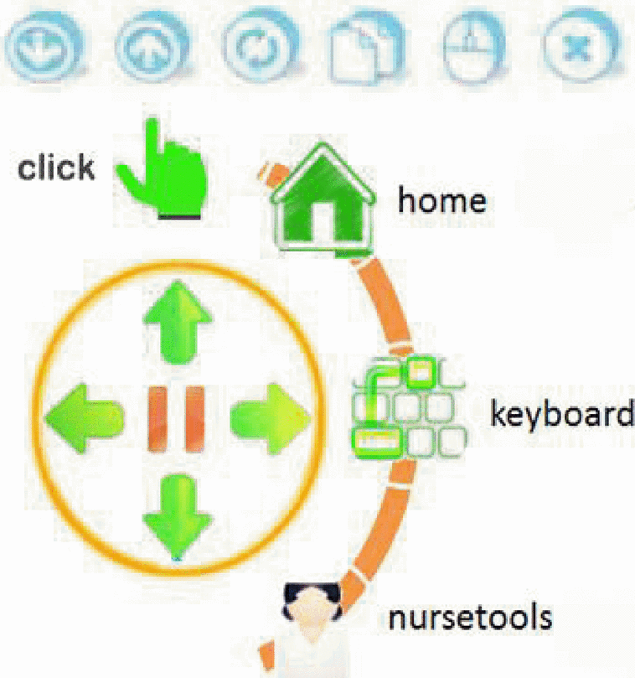

Fig. 1. Virtual Mouse

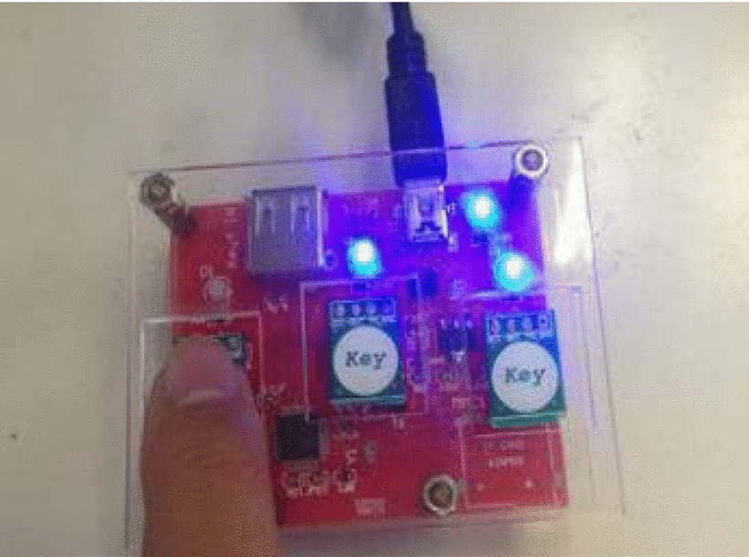

Fig. 2. Physical Mouse

If well designed and integrated, virtual input devices like the One Bit mouse can infinity expand the limits of traditional input devices. However, the limitation of such devices resigns precisely because it is virtual. It can only provide a layer of abstraction between some form of input and the action; a way to connect to it still needs to exist. As the mapping expands, this becomes increasingly difficult.

Motion Detection

Motion detection first took off with Xbox kinect for Just Dance, capturing human motion while dancing and reflecting this to the game as a new form of input used to calculate score.

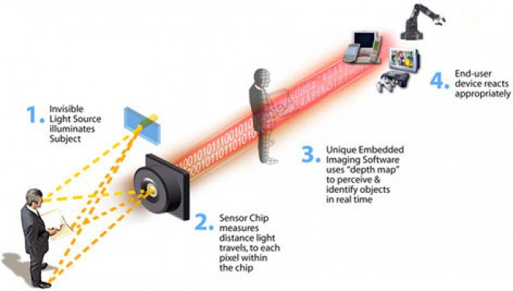

Fig. 3. How Kinect works

Unlike kinect, which uses IR light and their “time of flight” to generates a depth map [4], Leap Motion, another popular motion tracking technology uses algorithms to process gray scale stereo images of IR light spectrum instead [5].

Motion detection technologies can be easily integrated into VR because it preserves the presence of action in the physical world, generating the corresponding haptic feedback of motion, which would not be present if a button was simply pressed for the action. The main problem this is that the motion has achievable in real life, since it merely reflects the action conducted. This is imposes a huge limit its use to reflect input to a world where anything should be possible. Another problem is its reliability. In Slash The Fruit, a VR game using Leap Motion to track hand and arm motion for sword swings, users often found it difficult to manipulate an in-game sword [1].

Gaze Based Interaction

What we look at is often what we are interested in. Gaze Based Interaction offers a more natural way to interact with objects in VE’s, using the target of gaze to provide context to the input, similar to real life. Gaze based estimation also allows for the use of Level Of Detail algorithms, lowering the requirement on GPU for VR [6]. Despite the rising popularity of its use in immersive VR systems, most devices do not come with this technology [6] and it is still immature, costly, and uses large amounts of data. More commonly seen in use is using head gaze to estimate approximate gaze, reducing the cost and burden of data and computation.

Head gaze estimation, although less precise, still inherits the benefits of gaze based estimation. VREx, a VR game using head gaze estimation, provided a gaze only input system that allowed users to choose actions by looking a floating text panels and teleportation by looking at a butterfly [1]. An improvement, Dungeon VR, replaced the text panels with special markers, directly applying the appropriate action based on the context [1]. Main concern however, remains in terms of availability and the ability to correctly judge the context in all cases.

Brain Computer Interface (BCI)

Much of the research for BCI remain still under medical settings and still faces many challenges in terms of usability, training, transfer rate, etc… [2]. In addition, its high requirement on equipment makes BCI very expensive to implement. BCI is another technology that is not and will not be available in commercial settings for a long time to come.

Despite all of this, BCI hold unlimited potential. Studies have been conducted on the use of BCI as input to trigger interaction in VR. Examples of this include driving cars in VR cities [7] and controlling virtual avatars for rehabilitation [8]. Although it will not be possible at this point in time, if brain waves can be completely deciphered for meaning, then it could be directly used as input to VR. The scope of imagination is unlimited and this property transfers perfectly into VR as it also has infinite scope. The concern then would lay in the feasibility of creating a VR system that either has every possible option available, or could generate the options that does not exist. Limitations, or rules of the universe, could be applied to VR systems to force finite options, however, this defeats the ultimate goal of VR, which is to make anything possible.

Conclusion

Breakthroughs in VR have brought the technology into the forefront of innovation in many fields such as education, medical, and entertainment. VR has the ability to accomplish the seemingly impossible, bringing people into different places and situation right from their living rooms. Although the technology is still, immature in many ways, VR holds the potential to make anything possible.

In this paper, we have discussed several approaches to obtaining input to VE. Although physical controllers with the support of virtual controllers and motion detection are the norm today, the big trend is definitely moving towards the use of Gaze Based Interaction. BCI still remains to be but a far vision, but if realized, can hold unlimited potential in truly immersive VR.

References

R. Atienza, R. Blonna, M. I. Saludares, J. Casimiro and V. Fuentes, "Interaction techniques using head gaze for virtual reality," 2016 IEEE Region 10 Symposium (TENSYMP), Bali, 2016, pp. 110-114.

Sarah N. Abdulkader, Ayman Atia, Mostafa-Sami M. Mostafa, Brain computer interfacing: Applications and challenges, In Egyptian Informatics Journal, Volume 16, Issue 2, 2015, Pages 213-230, ISSN 1110-8665, https://doi.org/10.1016/j.eij.2015.06.002.

F. Jabeen, L. Tao and Tianlinlin, "One Bit Mouse for Virtual Reality," 2016 International Conference on Virtual Reality and Visualization (ICVRV), Hangzhou, 2016, pp. 442-446.

T. Carmody, “How Motion Detection Works in Xbox Kinect”, *Wired* [Online]. November 3, 2010 [Cit. 2017-10-13]. Available at: http://blog.leapmotion.com/hardware-to-software-how-does-the-leap-motion-controller-work/.

A. Colgan, “How Does the Leap Motion Controller Work?”, *Leap Motion* [Online]. August 9, 2014 [Cit. 2017-10-11]. Available at: http://blog.leapmotion.com/hardware-to-software-how-does-the-leap-motion-controller-work/.

A. M. Soccini, "Gaze estimation based on head movements in virtual reality applications using deep learning," 2017 IEEE Virtual Reality (VR), Los Angeles, CA, 2017, pp. 413-414.

X. Pan, Z. Zhang, J. Qu, C. Zhao and Y. Li, "Enjoy driving from thought in a virtual city," 2017 36th Chinese Control Conference (CCC), Dalian, 2017, pp. 11034-11040.

B. B. Longo, A. B. Benevides, J. Castillo and T. Bastos-Filho, "Using Brain-Computer Interface to control an avatar in a Virtual Reality Environment," 5th ISSNIP-IEEE Biosignals and Biorobotics Conference (2014): Biosignals and Robotics for Better and Safer Living (BRC), Salvador, 2014, pp. 1-4.